AstraZeneca vaccine rolling out on north shore
Where to get your COVID-19 jab on the north shore plus risks, options and timelines explained.
Margaret Rice
6 min read
April 14, 2021 - 12:00AM
Mosman Daily
0 comments
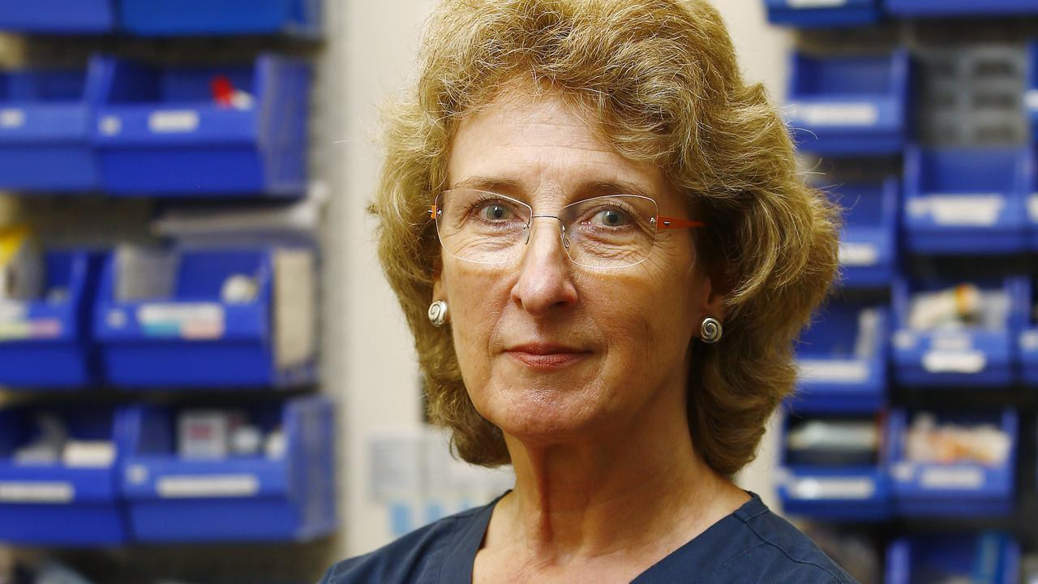
Dr Ann Allsop is on the frontline of the COVID-19 vaccine rollout. Picture: John Appleyard
Despite earlier anxieties about supplies and now very real worries about a small but disturbing risk of unusual blood clots, this week Dr Ann Allsop, of General Practice Cremorne, is vaccinating a busy schedule of patients against COVID-19.
With the AstraZeneca vaccine.
Last week cases of extremely rare blood clotting problems, called thrombosis and thrombocytopenia linked to the AstraZeneca vaccine, continued to emerge around the world. So the Australian Technical Advisory Group on Immunisation (ATAGI), gave new advice: AstraZeneca is recommended for those over 50, those under 50 should receive an alternative, most likely the Pfizer vaccine.
This week was to be the beginning of the rollout of COVID-19 vaccines, given by general practitioners such as Dr Allsop, all over the country - in outback towns and busy places like Cremorne.
But that’s now changed. Although it wasn’t going to happen for a while anyway, under 50s will now have to wait possibly many months to receive the Pfizer vaccine.
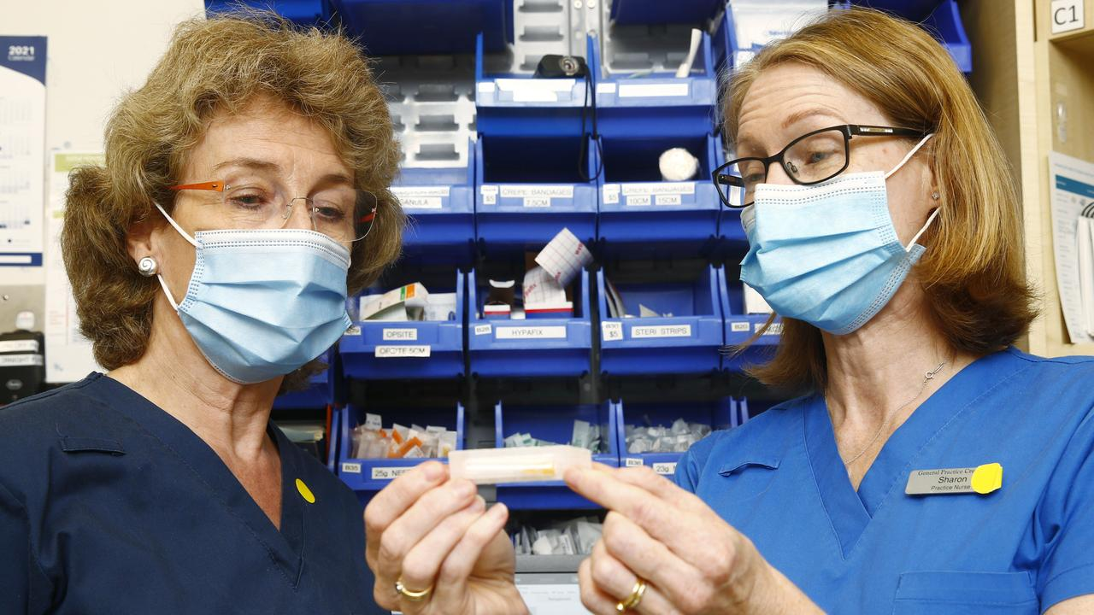
Dr Allsop speaks with Nurse Sharon Leaver. Picture: John Appleyard
So like other GPs, Dr Allsop no longer plans to routinely administer the AstraZeneca vaccine to under 50-year-olds. Yet Dr Allsop is still vaccinating now and for several weeks to come, at a rate of about 50 patients per week.
This is because, following the plan that was always in place, more than six million Australians can still be vaccinated. These are people over 70, health care workers, those in high risk work, such as paramedics, Aboriginal and Torres Strait Islander people over 55, and younger adults with an underlying medical condition which means COVID-19 is extremely risky for them.
“On the whole, my patients in these groups are still safe to be vaccinated and are still coming forward. We discuss together the risks from COVID-19 for them and whether these are outweighed by the risk of the vaccine. We review their medical histories together,” Dr Allsop says.
Symptoms of the serious blood clotting side effect include a severe headache which doesn’t respond to analgesics, vomiting, confusion and seizures. These symptoms would usually develop between four and 20 days after vaccination. If this happens to you, go back and seek medical attention urgently.
But most people will get a different side effects, and these are quite common; a temperature, feeling for a day as though you’re coming down with the flu. All of these are normal – and in fact, they show your body is doing the work it should in response to the vaccine - reacting by developing an immune reaction to COVID-19.
A medical worker holds a vial of the AstraZeneca vaccine in Rome, Italy. Picture: Andreas Solarao/AFP)
The confusion is worrying some patients. But Dr Allsop wants to be reassuring. Patients can make an appointment to talk about their worries.
The Pfizer vaccine is unlikely to be delivered through general practices, because the cold-chain delivery and storage needed with it will be difficult to manage outside large hubs.
Although the government has promised to secure another 20 million doses as quickly as possible, it will take a while for these to come through. They are likely to be delivered at large vaccine hubs, the details of which still have to be developed.
Dr Allsop, with more than 35 years experience in general practice, points out that doctors such as herself are always alert to the subtle differences between their patients’ needs.
“Whether the discussion is about the AstraZeneca vaccine for COVID-19 or another condition completely unrelated, we always consider what is safe for each individual. I’ll be answering any questions, talking through the risk factors with each one of my patients. These will depend on their age, what other diseases they suffer from and a range of factors.”
“I understand why people are worried. It’s hard to imagine taking risks with a vaccine to protect against a disease we’re not seeing here on Sydney’s lower north shore right now.
“But I’d like to reassure everyone that their safety is more important to us than meeting any vaccination schedule.”
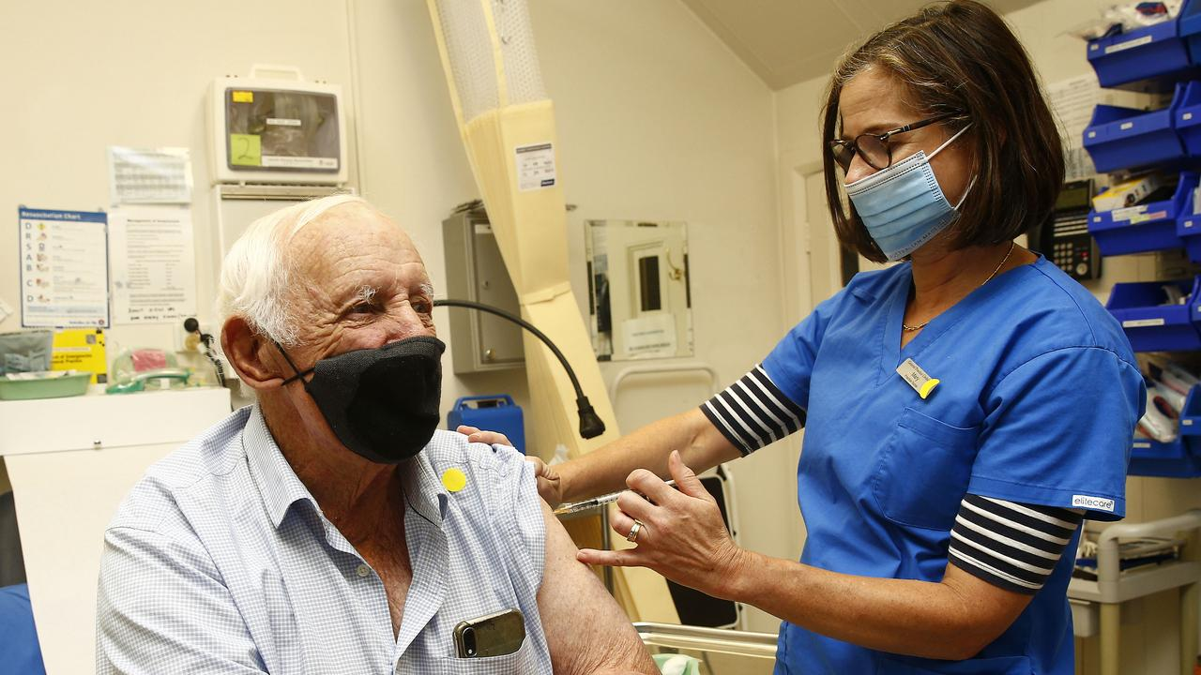
Mosman resident Philip Bull receives his AstraZeneca vaccination from Nurse Mary Fox at General Practice Cremorne. Picture: John Appleyard
While the lower north shore has have had virtually no COVID-19, the vaccine is a long-term ticket to safety, protecting Australians from waves of the disease coming from the rest of the world. And if we want to travel, break down COVID-19 state border barriers and get trade back on track, we need to get vaccinated.
Dr Allsop sees many lower north shore patients, who want to go overseas.
A typical mother, a little over 50 years old, might say ‘I want to see my daughter in London. I know there is a 1 in 200,000 risk of a blood clot from the vaccine for those under 50, but I’ve been told this is unlikely to happen to me. Without community vaccination, airlines won’t take me to London. So I want the AstraZeneca vaccine.’
Her decision is supported by the knowledge that the UK is only now coming out of lockdown, with 4,365,461 cases and 127,040 deaths. A little under 10 per cent of those with COVID-19 need intensive care and up to 70 per cent of those intensive care patients will get blood clots.
“So the risk of a blood clot from the vaccine is much lower than the risk of a blood clot from the disease. If she is over 50 we feel confident about supporting her and giving her the vaccine, as long as she understands the discussion around the blood clots,” says Dr Allsop.
Dr Penny Browne is Chief Medical Officer at Avant Mutual, the largest doctor’s indemnity organisation in Australia.
She had a key role in preparing more than half of Australia’s general practitioners for the vaccination program. This week she’s helping them adapt those plans and manage expectations – of those who want the vaccine regardless of the risks and those who will now be advised to consider alternatives.
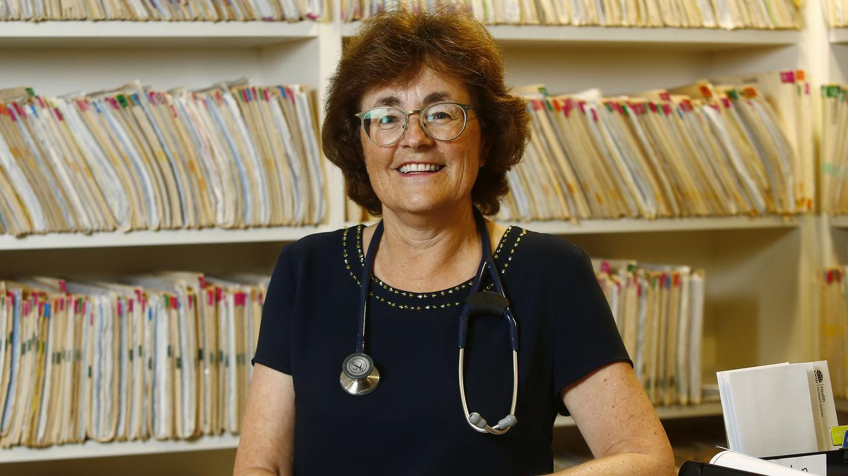
Dr Penny Browne is helping GPs plan the vaccine rollout. Picture: John Appleyard
Dr Browne lives in North Sydney and practises as a GP in the north of Sydney. Like Dr Allsop, she wants to find the balance between redirecting under 50-year-olds to wait and urging older Australians to continue with AstraZeneca and not to delay receiving their vaccination.
“Yes, getting the balance right between vaccinating and the risk of blood clots has created very big logistical challenges for us. But we’re aware of the need to protect people,” she says.
As at Dr Allsop’s practice, Dr Browne’s switchboard had been busy for weeks with people trying to make appointments to be vaccinated. Now this is mixed with calls from people who are worried and seeking more information specific to their circumstances.
“People are asking, ‘If I get a temperature after the vaccine, do I need a COVID-19 test?’ The answer is no, unless you have a sore throat and coughing. But if you’re not better after 48 hours, get in touch with your GP.
“If you suffer from asthma or any other lung disease, and you are over 50, we strongly urge you to go ahead and get the vaccine. You’re no more at risk than anyone else in your age group of having side effects - so many people worldwide have had the vaccine that we have evidence to be able to say this with a lot of confidence.
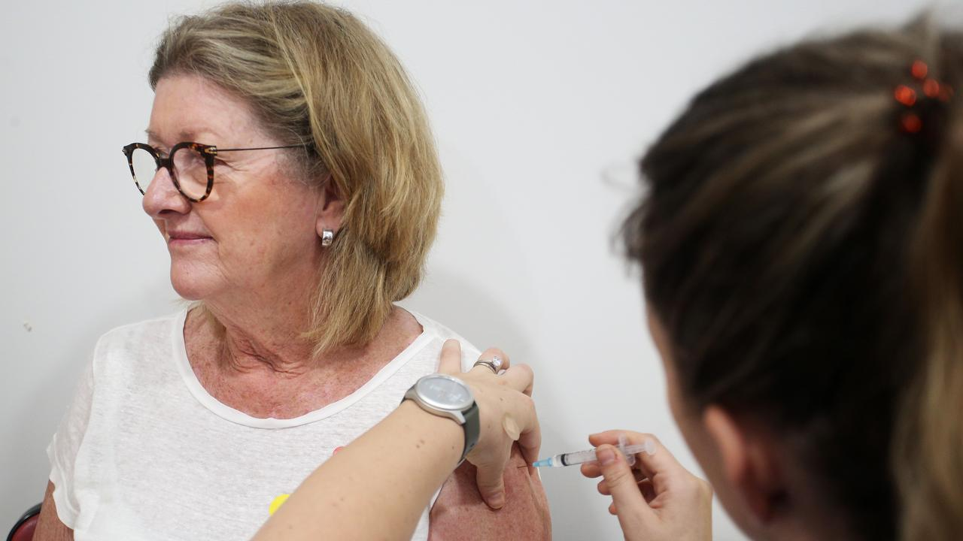
Dawne Yeates received the COVID-19 AstraZeneca vaccine from Nurse Emma McCallum at the Sydney Road Family Medical Practice in Balgowlah last month. Picture: Lisa Maree Williams/Getty Images
“The only absolute contraindication is if you have had an anaphylactic reaction to the AstraZeneca vaccine or any of the components of the vaccine before. So if you’ve had severe allergic reactions in the past, make sure your GP knows about this.
“If you have also had the very rare, severe clot in the brain called cerebral venous sinus thrombosis (CVST), you should talk to your GP about this too. But very few people will be in this category.”
Some people might become nervous after they’ve had their first shot, with the recent media attention.
“But I strongly urge you to still have that second shot. When you’ve had the first shot, you’ll have some antibodies within a couple of weeks. However, your antibody response won’t be able to continue to fight COVID-19 until it’s been boosted, so it won’t be complete until you’ve had the second vaccine.”
Here is the Federal Government’s website if you need more information:

More Coverage
Vaccine rollout in eastern suburbsSecond blood clot case ‘linked to vaccine’GPs refusing to give vaccine out of ‘fear’
https://www.health.gov.au/initiatives-and-programs/covid-19-vaccines
Information about how to receive the Pfizer COVID-19 vaccine will be available on the

